Section 1: Case Summary

Scenario Title:
Keywords: | Substance use, emergency medicine, SBIRT
Brief Description of Case: | A 29-year-old male presents to the emergency department (ED) after falling in the shower while intoxicated. He lost consciousness and does not remember the nature of the events that brought him to the ED. After performing an appropriate trauma evaluation and workup, learners should engage the patient in screening, brief intervention, and referral to treatment (SBIRT) to reduce his risk for future adverse outcomes related to his alcohol use.

Goals and Objectives
Educational Goals: | - Demonstrate ability to recognize alcohol-related traumatic injury and alcohol use disorder  - Demonstrate proficiency in utilizing a screening for alcohol use disorder, provide a brief intervention and referral to treatment in the ED
Objectives:  (Medical and CRM) | - List clinical features of presenting injury that should raise concern for alcohol use disorder  - Perform a screening for risky drinking, alcohol dependence and alcohol use disorder with a brief intervention effectively with referral to treatment in the ED
EPAs Assessed: | Emergency Medicine Milestones 2.0 (https://www.acgme.org/globalassets/pdfs/milestones/emergencymedicinemilestones.pdf)  - Patient Care 2: Performance of a Focused History and Physical Exam  - Patient Care 3: Diagnostic Studies  - Systems-Based Practice 3: System Navigation for Patient-Centered Care  - Interpersonal and Communication Skills 1: Patient- and Family-Centered Communication

Learners, Setting and Personnel
Target Learners: | Junior Learners | Senior Learners
Location: | Sim Lab
Recommended Number of Facilitators: | Instructors: 1
 | Sim Actors: 1
 | Sim Techs: None

Scenario Development
Date of Development: | 9/8/2022
Scenario Developer(s): | Anne Ickes, DO & Jessica Pelletier, DO
Affiliations/Institutions(s): | Dr. Ickes - Virginia Tech Carilion School of Medicine, Roanoke, VA  Dr. Pelletier - Washington University School of Medicine, St. Louis, MO
Contact Email: | akickes@carilionclinic.org, p.jessica@wustl.edu
Last Revision Date: | 12/30/2022
Revised By: | Anne Ickes, DO & Jessica Pelletier, DO
Version Number: | 3

Section 2A: Initial Patient Information

- Patient Chart
Patient Name: Chad |  |  |  | Age: 29 | Gender: M | Weight: 75 kg
Presenting complaint: Fall
Temp: 36.5 C | HR: 115 | BP: 130/80 |  | RR: 15 | O₂Sat: 96% RA | FiO₂: room air
Cap glucose: 4.5 mmol/L |  |  |  | GCS: 14 (E4 V4 M6)
Triage note: Passed out and fell in the shower. Girlfriend found him 6 hours later on the bathroom floor. Head hurts

Allergies: NKDA
Past Medical History: Depression, anxiety, opioid use disorder |  |  | Current Medications: Buprenorphine-naloxone, fluoxetine

Section 2B: Extra Patient Information

A. Further History
Include any relevant history not included in triage note above. What information will only be given to learners if they ask? Who will provide this information (mannequin’s voice, sim actors, SP, etc.)?

HPI/RoS (Provided by patient and girlfriend):
- Was taking a shower after having a few drinks and does not really remember what happened after that
- Woke up in an ambulance
- Per girlfriend, it had been about 6 hours since he had last texted her. This has happened a few times before
- Reports having a mild headache
- Denies neck pain, weakness, numbness, tingling, vision changes, trouble swallowing or speaking. Has not tried walking yet

Social history:
- Former IV drug use with heroin - has been in remission for 5 years since he started buprenorphine-naloxone at 8-2 mg BID and enrolled in an office-based opioid treatment program
- No tobacco use
- When you ask him if he drinks alcohol, he says, “Yeah, a bit,” but does not elaborate. His girlfriend shoots him a dirty look but neither of them seem willing to offer up more information

B. Physical Exam
General appearance: Disheveled male who smells of body odor and alcohol. No acute distress
Cardio: Tachycardic but regular rhythm | Neuro: Opens eyes spontaneously. Oriented to person but not place or situation. Occasionally asks the learner to repeat questions. Follows commands. CN II-XII intact, 5/5 strength bilateral upper and lower extremities, sensation intact, no ataxia, aphasia, dysarthria, dysdiadochokinesia. Normal gait. Negative Romberg
Resp: Normal | Head & Neck: Scalp hematoma, Battle’s sign, or raccoon eyes. No cervical midline tenderness.
Abdo: Soft, non tender  Psych: no signs of obvious intoxication, flat affect, speech normal rate and tone, dysthymia present | MSK/skin: No extremity ecchymoses. Full ROM all extremities. No tenderness, crepitus, step-off, or deformity of midline spine

Section 3: Technical Requirements/Room Vision

A. Patient
☐ Standardized Patient
B. Special Equipment Required
Cervical collar

C. Required Medications
Acetaminophen or ibuprofen for pain control

D. Moulage
Moulage to the left parietal scalp to simulate hematoma

E. Monitors at Case Onset
Patient on monitor with vitals displayed

F. Patient Reactions and Exam
Include any relevant physical exam findings that require mannequin programming or cues from patient
(e.g. – abnormal breath sounds, moaning when RUQ palpated, etc.) May be helpful to frame in ABCDE format.

Chad should avoid eye contact with the learner, acting embarrassed regarding his presentation. He should be especially hesitant to discuss the circumstances of his presentation when asked if he remembers what he was doing prior to losing consciousness or if there was any alcohol involved.

When Chad is being screened for alcohol use disorder, he should have some hesitancy but also realization of his alcohol problem, demonstrating a precontemplative state.

Section 4: Sim Actor and Standardized Patients

Sim Actor and Standardized Patient Roles and Scripts
Role | Description of role, expected behavior, and key moments to intervene/prompt learners. Include any script required (including conveying patient information if patient is unable)
Standardized Patient | If the learner does not offer pain medication for the headache, the patient should ask for it.  If the learner does not discuss with the patient what type of pain medication the patient would prefer (opioid vs. non-opioid) and simply orders an opioid, the patient should express frustration with the nurse and request to speak to the doctor. The patient will request acetaminophen or ibuprofen.  If the learner performs the screen without explaining what the screening tools are and how they are used, the patient should become offensive and angry.  If the learner does not re-address their concerns that the patient may have been drinking to excess prior to the fall, the facilitator should take the role of the RN and say, “Doc, the girlfriend just told me that Chad has a drinking problem. Do you think we should talk to him about that?” and should hand the learner printed copies of the AUDIT-C and CAGE questionnaires (Appendices 1-2).  If a brief intervention is not performed by providing education, support, or motivation, the patient should dismiss the learner’s attempt to consult social work or hand him written resources until the patient is given a reason why these things are being done. The patient should continue to ask why these resources are being given until the learner provides an intervention.

Section 5: Scenario Progression

Scenario States, Modifiers and Triggers
Patient State/Vitals | Patient Status | Learner Actions, Modifiers & Triggers to Move to Next State |  | Facilitator Notes
1. Baseline State  Rhythm: Sinus tachycardia  HR: 115 bpm  BP: 130/80  RR: 15  O₂SAT: 96% RA  T: 36.5ºC  GCS: 14 | Awake, alert, disheveled, avoiding eye contact, somewhat confused | Expected Learner Actions  ☐ Conducts primary and secondary trauma surveys  ☐ Consider cervical collar during primary survey  ☐ Consider CT head/cervical spine based on mechanism of injury  ☐ Appropriately medicates for pain | Modifiers  Changes to patient condition based on learner action  - If the learner does not offer pain medication for the headache, the patient should ask for it  Triggers  For progression to next state  - CT head/cervical spine obtained | If the learner does not discuss with the patient what type of pain medication the patient would prefer (opioid vs. non-opioid) and simply orders an opioid, the patient should express frustration with the nurse and request to speak to the doctor. The patient will request acetaminophen or ibuprofen
2. CT head/cervical spine negative, pain medication administered | GCS 15 | Expected Learner Actions  ☐ Screen for alcohol use disorder using one of the following AUDIT-C/AUDIT or CAGE plus NIAAA consumption question  - Perform a brief intervention at the bedside with patient education or increasing motivation to decrease use  ☐ Consult to social work or provide resources with a referral to treatment | Modifiers  - Tries to elope from the ED if drinking is not addressed  Triggers  - Learner consults social work for referral resources or provides direct referral to treatment which ends the case | If the learner does not re-address their concerns that the patient may have been drinking to excess prior to the fall, the facilitator should take the role of the RN and say, “Doc, the girlfriend just told me that Chad has a drinking problem. Do you think we should talk to him about that?” and hands them forms for the AUDIT-C/CAGE questionnaires.  The patient scores an 8 on AUDIT-C and a 3 on the CAGE questionnaire.

Appendix A: Laboratory Results

CBC  WBC 6.0 × 10⁹ cells/μL  Hgb 11.2 mmol/L  Plt 250 × 10⁹ cells/L  Lytes  Na 138 mmol/L  K 3.9 mmol/L  Cl 100 mmol/L  HCO₃ 26 mmol/L  AG 12  Urea 7.1 mmol/L  Cr 79.6 µmol/L  Glucose 4.7 mmol/L  Extended Lytes  Ca 2.3 mmol/L  VBG  PH 7.36  PCO₂ 45 mmHg  PO₂ 40 mmHg  HCO₃ 26 mmol/L  Lactate 1.8 mmol/L | Biliary  AST 120 units/L  ALT 60 units/L  ALP 60 units/L  Bili 10.3 μmol/L  Lipase 32 units/L  Tox  EtOH 54.3 mmol/L

Appendix B: ECGs, X-rays, Ultrasounds and Pictures

Paste in any auxiliary files required for running the session. Don’t forget to include their source so you can find them later!

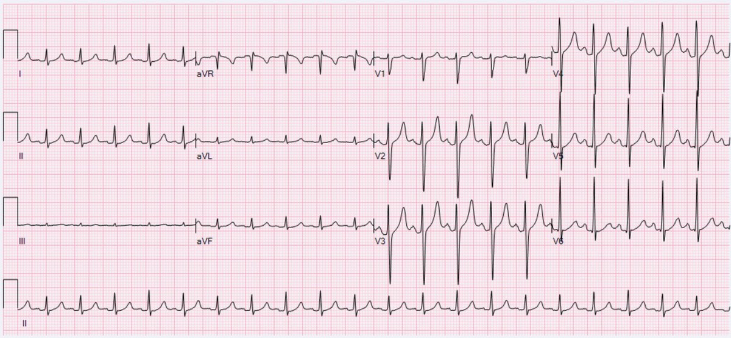
https://en.wikipedia.org/wiki/Sinus_tachycardia

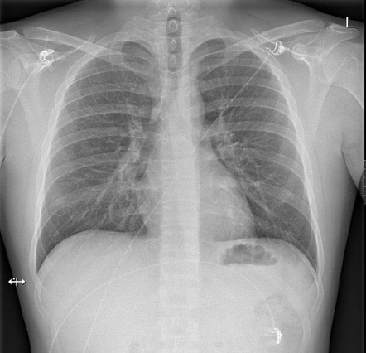
https://radiopaedia.org/cases/normal-chest-radiograph-male?lang=us

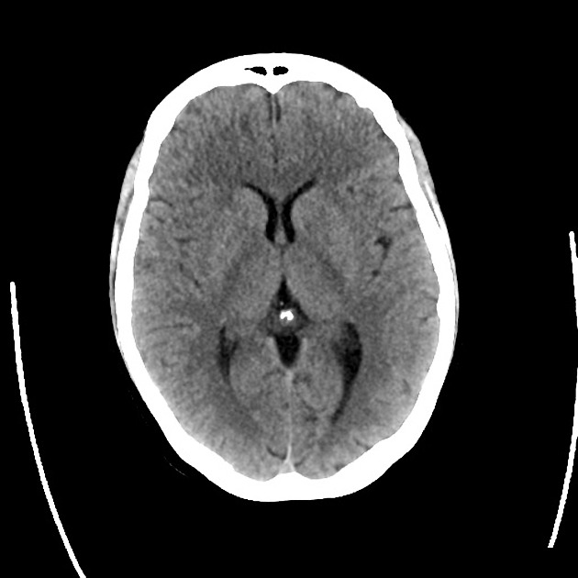
https://radiopaedia.org/cases/normal-ct-brain-pre-and-post-contrast?lang=us
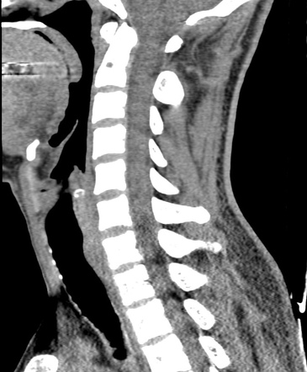
https://radiopaedia.org/cases/normal-cervical-spine-ct-1

Appendix C: Facilitator Cheat Sheet & Debriefing Tips

Include key errors to watch for and common challenges with the case. List issues expected to be part of the debriefing discussion. Supplemental information regarding any relevant pathophysiology, guidelines, or management information that may be reviewed during debriefing should be provided for facilitators to have as a reference.

This case highlights the importance of recognizing alcohol-related injury and conducting SBIRT in the ED after critical, life-threatening injuries have been ruled out. Alcohol-related traumatic injury is unfortunately incredibly common. It has been found that over ⅓ of traffic accidents involving individuals 16-20 involve alcohol and that 40% of traumatic deaths involve alcohol and/or drugs.^{1,2} Alcohol use markedly increases the risk of injury, and greater consumption portends greater risk.^{3,4} Since we are the front lines physicians encountering those with traumatic injuries, we are in a unique position to identify those at risk for alcohol use disorder and provide them with the resources they need to prevent future harms.

Screening, brief intervention and referral to treatment (SBIRT) is an established public health initiative to identify and intervene on patients who are at risk or have a substance use disorder. SBIRT as a modality dates back to the 1980’s as screening tools became more available and was first most notable for intervening on alcohol misuse.^{5,6} First, a screen is performed using questions about how alcohol may or may not affect their life. Alcohol Use Disorder Identification Test (AUDIT) is a 10 question survey to identify risk for more severe alcohol use and a shortened version related to consumption is AUDIT-C that can be used to identify risky use. A common screening tool, Cut Down, Annoyed, Guilty, Eye opener (CAGE), is not recommended as it only screens for dependence but not risky use. The National Institute on Alcohol Abuse and Alcoholism (NIAAA) recommends if CAGE is performed then a one question about consumption must precede asking if they have consumed more than 5 or more drinks on occasion for men and 4 or more for women. After the screen is performed and the patient is deemed to be at risk or positive, a brief, 2-3 minute, intervention is performed. A brief intervention can include increasing motivation to decrease use, providing patient education, or teaching skills to decrease use.⁷ At this point a referral to treatment can be done by a provider or a social worker to engage the patient into further treatment including psychotherapy and pharmacotherapy.

CAGE QUESTIONNAIRE^{8*}
Have you ever felt you needed to Cut down on your drinking?
Have people Annoyed you by criticizing your drinking?
Have you ever felt Guilty about drinking?
Have you ever felt you needed a drink first thing in the morning (Eye-opener) to steady your nerves or to get rid of a hangover?
*Scores of 2 are 93% sensitive for excessive alcohol intake and 91% sensitive for alcohol use disorder.

AUDIT-C^{9**}
How often did you have a drink containing alcohol in the past year?
Never
Monthly or less
Two to four times a month
Two to three times per week
Four or more times a week
How many drinks containing alcohol did you have on a typical day when you were drinking in the past year?
1 or 2 drinks
3 or 4
5 or 6
7 to 9
10 or more
How often did you have six or more drinks on one occasion in the past year?
Never
Less than monthly
Monthly
Weekly
Daily or almost daily
**Scores of 3 or more for females or 4 or more for males are concerning for alcohol misuse.

SBIRT programs have been demonstrated to be effective in reducing alcohol use in the short term.¹⁰ Studies have shown that telephone-delivered SBIRT can be successfully established and maintained and can be equally effective to in-person SBIRT for ED patients.^{11,12} A recent systematic review found evidence of moderate quality suggesting that ED-based SBIRT programs help reduce alcohol-related injuries, reduce alcohol consumption in individuals with mild to moderate alcohol use disorder, and reduce repeat ED visits.¹² Until we have evidence to suggest otherwise, we should be using SBIRT to promote harms reduction in our patients with alcohol use disorder.

References

- Conference Proceedings on Alcohol- and Drug-Related Injuries. Home page at: http://www.cdc.gov/ncipc/Spotlight/2003_Alcohol_Conference_Proceedings.htm (2003). Accessed 12 May 2010.
- Plurad D, Demetriades D, Gruzinski G, Preston C, Chan L, Gaspard D, Margulies D, Cryer HG. Pedestrian injuries: the association of alcohol consumption with the type and severity of injuries and outcomes. J Am Coll Surg. 2006;202:919–27. doi: 10.1016/j.jamcollsurg.2006.02.024.
- Salim A, Ley EJ, Cryer HG, Margulies DR, Ramicone E, Tillou A. Positive serum ethanol level and mortality in moderate to severe traumatic brain injury. Arch Surg. 2009;144:865–71. doi: 10.1001/archsurg.2009.158.
- Madan AK, Yu K, Beech DJ. Alcohol and drug use in victims of life-threatening trauma. J Trauma. 1999;47:568–71. doi: 10.1097/00005373-199909000-00026.
- Substance Abuse and Mental Health Services Administration. About screening, brief intervention, and referral to treatment (SBIRT). 2022. https://www.samhsa.gov/sbirt/about
- Babor TF, McRee BG, Kassebaum PA, Grimaldi PL, Ahmed K, Bray J. Screening, brief intervention, and referral to treatment (SBIRT): Toward a public health approach to the management of substance abuse. FOCUS. 2011;9(1):130-148. doi:10.1176/foc.9.1.foc130.
- National Institute on Alcohol Abuse and Alcoholism. Helping Patients Who Drink Too Much: A Clinician’s Guide. 2005 Edition.Bethesda, MD: National Institute on Alcohol Abuse and Alcoholism; 2005. NIH publication No. 05-3769 https://pubs.niaaa.nih.gov/publications/practitioner/cliniciansguide2005/guide.pdf
- Ewing JA. Detecting alcoholism. The CAGE questionnaire. JAMA. 1984 Oct 12;252(14):1905-7. doi: 10.1001/jama.252.14.1905. PMID: 6471323.
- Bush K, Kivlahan DR, McDonell MB, Fihn SD, Bradley KA. The AUDIT alcohol consumption questions (AUDIT-C): an effective brief screening test for problem drinking. Ambulatory Care Quality Improvement Project (ACQUIP). Alcohol Use Disorders Identification Test. Arch Intern Med. 1998 Sep 14;158(16):1789-95. doi: 10.1001/archinte.158.16.1789. PMID: 9738608. https://pubmed.ncbi.nlm.nih.gov/9738608/
- Bruguera P, Barrio P, Manthey J, et al. Mid and long-term effects of a SBIRT program for at-risk drinkers attending to an emergency department. Follow-up results from a randomized controlled trial. European Journal of Emergency Medicine. 2021;28(5):373-379. doi:10.1097/MEJ.0000000000000810
- Harrison L, DeMasi L, Butkus S, et al. 163 Implementation of a Telephonic-Based Model to Continue to Address Substance Use as Part of Usual Care in Emergency Departments during COVID-19. Annals of Emergency Medicine. 2020;76(4):S64. doi:10.1016/j.annemergmed.2020.09.175
- Davis-Martin R, Gibbons B, Barnosky A, Aldridge A, Boudreaux E. Changes in alcohol use following telephone-delivered screening, brief intervention, and referral to treatment: Results of a randomized controlled trial among emergency department patients. Acad Emerg Med. 2021;28(S1). doi:10.1111/acem.14249
- Barata IA, Shandro JR, Montgomery M, Polansky R, Sachs CJ, Duber HC, Weaver LM, Heins A, Owen HS, Josephson EB, Macias-Konstantopoulos W. Effectiveness of SBIRT for Alcohol Use Disorders in the Emergency Department: A Systematic Review. West J Emerg Med. 2017 Oct;18(6):1143-1152. doi: 10.5811/westjem.2017.7.34373. Epub 2017 Sep 21. PMID: 29085549; PMCID: PMC5654886.

Template Credit: EM Sim Cases Template (https://emsimcases.com/template/)

Appendix 1 - Printable AUDIT-C Questionnaire

Patient Name ____________________________________ Date of Visit ______________________

1. Within the past year, how often did you have a drink of alcohol?
□ a. Never
□ b. Monthly (e.g. Special occasions/Rare)
□ c. 2-4 times a month (e.g. 1x on weekend - “Fridays only” or “every other Thursday”)
□ d. 2-3 times a week (e.g. weekends – Friday-Saturday or Saturday-Sunday)
□ e. 4 or more times a week (e.g. daily or most days/week)

2. Within the past year, how many standard drinks containing alcohol did you have on a typical day?
□ a. 1 or 2
□ b. 3 or 4
□ c. 5 or 6
□ d. 7 to 9
□ e. 10 or more

3. Within the past year, how often did you have six or more drinks on one occasion?
□ a. Never
□ b. Less than monthly
□ c. Monthly
□ d. Weekly
□ e. Daily or almost daily

Scoring: a = 0 points, b = 1 point, c = 2 points, d = 3 points, e = 4 points
In men, >/= 4 is positive
In women, >/= 3 is positive

Source: https://anthc.org/wp-content/uploads/2017/05/Audit-C.pdf

Appendix 2 - Printable CAGE Questionnaire

1. Have you ever felt you should cut down on your drinking?
2. Have people annoyed you by criticizing your drinking?
3. Have you ever felt bad or guilty about your drinking?
4. Have you ever had a drink first thing in the morning to steady your nerves or to get rid of a hangover (eye-opener)?

Scoring: no = 0 points, yes = 1 point; >/= 2 is clinically significant

Source: https://www.hopkinsmedicine.org/johns_hopkins_healthcare/downloads/all_plans/CAGE%20Substance%20Screening%20Tool.pdf

